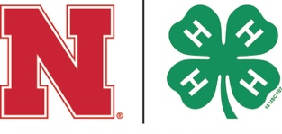

2024 4-H PROJECTS
Visit 4hcurriculum.unl.edu for more information about these projects and their resources. Some counties may offer additional county-level projects. Nebraska 4-H’s enrollment deadline for participation in county and state fairs is June 15 of the current year. Some counties may have an enrollment fee. Contact your local Extension office for more information.

ANIMAL SCIENCE
Beef
Cat
Dairy Cattle
Dog
Goat
Horse
Poultry
Rabbit
Sheep
Swine
Veterinary Science
Other Pet or Small Animal

COMMUNICATIONS & EXPRESSIVE ARTS
Communications
Photography
Visual Arts

CONSUMER & FAMILY SCIENCES
Consumer Education
Home Design, Improvement & Restoration
Human Development
Textile, Quilts & Apparel

CLOVER KIDS

ENVIRONMENTAL EDUCATION & EARTH SCIENCE
Conservation & Wildlife
Entomology
Forestry

HEALTHY LIFESTYLES
Healthy Lifestyles
Safety

LEADERSHIP, CITIZENSHIP & PERSONAL DEVELOPMENT
Citizenship
Entrepreneurship
Leadership

PLANT SCIENCE
Agronomy
Horticulture
Range

SCIENCE, TECHNOLOGY, ENGINEERING & MATHEMATICS
Aerospace
Computers
Electricity
Energy
Geospatial
Physics
Robotics
Welding
Woodworking

SHOOTING SPORTS
22 Rifle
Air Pistol
Air Rifle
Archery
BB Gun
Hunting Skills
Muzzleloader
Shotgun
Smallbore Pistol

