Research Questions
- Would it be possible to do surgery on Mars?

- What possible challenges will we run into doing surgery on Mars?

- What kind of power will you use to run the ER?

- What tools do you need in your ER?

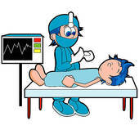
- How are you transporting your tools to Mars?

